2023
Internal Audit Department
Khalifa University of Science and Technology
April - 2023


Internal Audit Report
UAE- Korea Joint R&D Technical Center (KUTC)

Ref: KU/2023/IAD-138
April 2023

Sir John James O Reilly
Khalifa University of Science and Technology

We have completed our review of UAE- Korea Joint R&D Technical Center (KUTC). The review was conducted during February – April 2023 covering the period from January 2022 to December 2022.

The objective of our audit was to review the adequacy and effectiveness of internal controls system and procedures; and to ensure compliance with operating policies and procedures, laws and regulations.

We have discussed the contents of our report, including our recommendations, with the respective processes’ owners and where relevant we have incorporated their comments and action plans to remediate our findings.

I would like to draw your attention to the issues highlighted in the executive summary, where opportunities for improvement were highlighted.

Yours Sincerely,

Abdulaziz Alkhoori
VP, Audit

Table of Contents

1. Executive Summary 4
1.1 Introduction 4
1.2 Scope of Work 4
1.3 Audit Objectives 4
1.4 Audit Process 4
2. Summary of Audit Findings 4
3. Background 5
4. Detailed Audit Findings 6
5. Appendix 12

- Executive Summary
  - Introduction
We have completed the Review of UAE- Korea Joint R&D Technical Center (KUTC), in line with the Approved Internal Audit Plan and Scope Letter Dated February 2023. The Internal Audit Findings / Improvement Opportunities to address associated risks / control gaps were identified and reported as part of this report.
  - Scope of Work
The Scope of Work comprised of the following areas:
- Governance and Compliance.
- Operations.
- Budget / Intellectual Property and Compliance with Agreement
  - Audit Objectives
The Objective of this review is to provide independent and objective assessments of KU’s business processes and systems of risk management, internal controls and governance processes. Further, assess compliance with policies/procedures and efficiency and effectiveness of operations and resource utilization.
  - Audit Process
The following are the key Audit Steps undertaken by the IA Department:
- Gain an understanding of the processes of the areas covered in the scope listed above.
- Reviewed adequacy and effectiveness of internal controls system and procedures.
- Reviewed compliance with the policies and procedures, laws and regulations.
- Agreed with process owners on action plans to improve control effectiveness / process performance.
- Summary of Audit Findings
Controls need to be enhanced for 20% of the observations. A balance of 60% is within the moderate range and 20% is within the low range and needs to be monitored and prevented from entering the high-risk category and moderate range as applicable.

Please refer to Appendix – 1 for detailed Ratings
The audit findings found during the review are summarized below. It should be noted that we have reported only on the exceptions detected during the course of our review.
- KUTC Strategic Direction
- Co-funding from external stakeholders has not been attained and Advisory Board has not been established as per KUTC Strategic objectives.
- Absence of near term (1-2 years) and long-term (5 years) KUTC strategic plans.
- Decision on Center continuation / discontinuation has not been made resulting in lack of alignment with KU Plan 2031.
- KUTC Lab
- Underutilization of KUTC Lab space & equipment due to no research projects in-progress & proposals under review.
- Lack of invoicing to KBSI for installation & operational costs of KUTC Lab & Office resulting in non-compliance with Agreement.
- Lack of separate agreement signed by authorized representatives to agree on amendments to the Agreement.

- Background
A Memorandum of Understanding (MoU) was signed Between Korea Basic Science Institute (KBSI) and Khalifa University (KU) on 01 November 2018 which required Establishment of a Korea-UAE Joint R&D Technical Center. The Agreement for establishment of KUTC was signed on 26 November 2019 which was effective from 30 June 2019 (for 5 years).
- Center Vision
To be an open research platform in the UAE.
- Center Mission
- Support and upgrade UAE research infrastructure;
- Facilitate collaborative R&D between the UAE and Korea;
- Develop a scientific exchange hub in the UAE;
- Build joint research laboratories.
- Strategic Goals and Objectives of the Center
KUTC Plan for developing collaboration projects under KUTC and strategic directions was developed in July 2020 covering the following:
- Identifying more stakeholders from UAE side (government and industry sectors) to secure the co-funding in order to extend research focused areas into energy, catalysts, health, oil & gas, semiconductors, etc.
- Building up advisory board by inviting top management from potential stakeholders nationally.
- Acquiring physical space within campus for improving visibility of the center and effective interaction with other research centers.
- Acknowledging KUTC on the publications with KUTC staff’s engagement.
- Center Budgeting
A separate budget code is not assigned for the center i.e. 0 budget for the Research Center. Budget vs Actuals and project account codes are created for individual Research Projects initiated under KUTC. The agreement for the establishment KUTC have no specified budget commitments from either parties although some cost responsibilities were assigned in the Center Agreement.
- Research Projects
One collaborative Research Project has been completed since the establishment of the Center.
- Reporting and Monitoring of the Center
Periodic KUTC Research Project reports are shared with KU Research Management. Further, KUTC Steering Committee is established for periodic review of the Center Progress which comprises of 4 members including SVP R&D and KUTC Center Director from KU as well as 2 KBSI representatives.
- Key highlights from the KUTC Agreement
Following are key highlights from the Agreement:
- Operate laboratory in the UAE for Korea Basic Science Institute (KBSI) and KU researchers to participate in joint research.
- KU will provide office and laboratory space for KUTC together with administrative support.
- KU will make available the pre-existing facilities and equipment for the KUTC, together with suitable office space. Subject to the approval of the Steering Committee, KU may make available different additional laboratory and/or office space and/or equipment for the KUTC, under terms and conditions to be contained.
- KU will make available the pre-existing facilities and equipment for the KUTC, together with suitable office space. Subject to the approval of the Steering Committee, KU may make available different additional laboratory and/or office space and/or equipment (as specified in Appendix 2) for the KUTC, under terms and conditions to be contained in a separate legal agreement. KBSI will be responsible for the cost associated with the installation and/or operation of any such laboratory and/or office space.
- Subject to the terms of Clause 8-6, the Steering Committee may make significant decisions regarding amendments to this Agreement.
- No variation or amendment of this Agreement will be effective unless it is made in writing and signed by each Party's duly authorized representative.
- Detailed Audit Findings
● High | - KUTC Strategic Direction
Risk Ref : KUTC-05
Observation/Process Enhancement
- KUTC Strategy
Our review of KUTC Strategy developed in July 2020 showed following status for 2 out of 4 objectives:
- Identification of more stakeholders from UAE side (government and industry sectors) to secure the co-funding in order to extend research focused areas.
Our review showed additional co-funding from more stakeholders (UAE side) either government or industry sectors has not been attained. Since 2019, only one collaborative research project under KUTC was initiated and completed, co-funded by KU and KBSI i.e. the original signing parties to the Agreement.
- Building up advisory board by inviting top management from potential stakeholders nationally.
Our review showed absence of advisory board setup with stakeholders nationally.
- KUTC Short Term and Long Term Plans
As per July 2020 KUTC Steering Committee presentation, KUTC Strategic Planning required development of strategic plans for near term (1-2 years) and long-term (5 years). However, our review showed absence of both short term and long term strategic plans for KUTC.
- KUTC Strategy Alignment with KU Research Strategy
Our review of KU Plan 2031 – Research and Development showed lack of alignment of KUTC as a research center with Proposed Future Research Focus Areas (Horizontals / Verticals / Research Themes etc.) of KU. This is due to the fact that the decision on center renewal was to be decided by December 2022, as on 17 March 2023, there has been no decision to continue or discontinue the Center and KUTC remains unaligned with research priorities of KU Plan 2031.
It is worthy to note that the Memorandum of Understanding expires in Oct 2023 (Approx. 6 months) while the research center agreement expires in June 2024 (Approx. 1 year).
Recommendations
- Ensure Strategic Objectives are achieved and their status is periodically reported to KUTC Steering Committee / KU Management covering the including setting up advisory board and securing co-funding to extend center research focused areas.
- Ensure Strategic Plans (Short term and long term) are established and presented to KUTC Steering Committee.
- Ensure adequate alignment between KUTC Strategy and KU Research Strategy. Further, ensure KU Plan 2031 identify KUTC contribution to its overall objectives.
- Follow up with KU Management on the decision on Center Continuation / discontinuation to ensure timely renewal non-renewal of MoU and Research Center Agreement.
Management Action Plan
Management Action Plan:

Responsibility:

Timelines:

● Medium | - Key Performance Indicators
Risk Ref : KUTC-05
Observation/Process Enhancement
- KPIs
Our review of the KUTC noted absence of Strategic and Short Term Center Key Performance Indicators (KPIs). As a result, there is no formal mechanism to gauge / track progress against targets of the Center, provide a focus for strategic and operational improvement, create an analytical basis for decision making and help focus attention towards Center Vision and Objectives.
- Lack of Formal Center Monitoring and reporting within KU
At KU, in addition to Senior Management Boards / Steering Committees of the respective Research Centers monitoring center performance, detailed periodic center reports are submitted to either University Sponsored Research (USR) or Office of Research Services (ORS) depending on the type of funding (internal or external). These offices typically facilitate research administration at KU.
However, our review showed the absence of formal Center reporting on KUTC to either USR or ORS.
Recommendation
- Establish and obtain approval on Short Term and Strategic KPI’s.
- Periodically report on status of KPIs to KUTC Steering Committee and KU Management.
- Explore possibility of ORS or USR being involved in reviewing Center reports periodically.
Management Action Plan
Management Action Plan:

Responsibility:

Timelines:

● Medium | - KUTC Steering Committee
Risk Ref : KUTC-01
Observation/Process Enhancement
KUTC Steering Committee is established to periodically review Center progress. The committee comprises of 2 representatives from KU and KBSI. During our review, we noted only 3 KUTC Steering Committee meetings were held during 2019 and 2022, resulting in non-compliance with the Agreement which requires committee meetings to be held on quarterly basis.
Further, in 2 of the 3 Steering Committee Meetings held in 2019-2022, the meetings were not attended by all members. In absence of Committee Charter and Agreement defining quorum requirements, voting rights & rules, etc., it is unclear whether proceedings of the 2 meetings are valid.
Lastly, formal signatures from members of the committee are not obtained on minutes of the meeting.
Recommendations
- Ensure Compliance with the Agreement with regards to periodicity of meetings.
- Ensure Charter for the Committee is established including Quorum requirements, voting rights & rules etc. compliance with charter shall be ensured, monitored and reported.
- Ensure formal signatures from committee members are obtained on minutes of meetings.
Management Action Plan
Management Action Plan:

Responsibility:

Timelines:

● Medium | - KUTC Budget
Risk Ref : KUTC-02
Observation/Process Enhancement
Short term and strategic budgets are required for Research Centers to ensure continuation of their operations. During our review, we noted 0 dedicated budget / budget code for the Center since its establishment in 2019.
Further, although KUTC Lab, KUTC Office as well as Joint Research Workshop were conducted under the umbrella of KUTC, the expenses were funded from other KU budget codes. For instance, a computer equipment in KUTC Lab for AED 17K purchased in 2022 and KUTC Joint Research Workshop expenses were funded from Office of Research and Development budget code.
Recommendations
- Evaluate and explore possibility of establishing short and long term budget supporting objectives of the Center.
- Explore possibility of setting a separate account code to budget for KUTC.
- Ensure all KUTC related expenses are accounted for against its budget to support expenditure monitoring and reporting.
- Ensure periodic monitoring and reporting of budget vs actuals to Steering Committee and KU Management.
Management Action Plan
Management Action Plan:

Responsibility:

Timelines:

● Medium | - Research Center Agreement
Risk Ref : KUTC-11
Observation/Process Enhancement
KUTC Agreement highlights various responsibilities of both parties i.e. KU and KBSI. During our review of the Agreement we noted no monetary value is described in the Agreement i.e. in-kind contribution by KU towards the Center over a period of 5 years for elements such as:
- Contribution (time and efforts) of KU’s Director Research Laboratories and KU’s KUTC Center Director
- KU providing office and Laboratory space as well as utilities (Electricity, Water);
- KU providing administrative support (Procurement, HR, Finance etc.).
When compared to other Research Center Agreements such as ENTC or ARIC, indirect / in-kind contributions are defined in Center Agreements in monetary terms which helps identify contribution of each signing party. As a result, in absence of budgeted indirect / in-kind contributions by KUTC and KBSI, it is unclear how much each party will be and has contributed towards KUTC.
It is worthy to note, as per the new Delegation of Authority (October 2022), approval authorities are now described for Academic Partnership Agreements (including “in kind” partnership or operational arrangements).
Recommendations
- Review KUTC Agreement and identify budgeted indirect contribution by each signing party.
- Explore possibility of formally highlighting budgeted in kind contribution to KUTC Steering Committee or Addendum.
- Monitor and report on actual in-kind contributions by both parties on periodic basis.
Management Action Plan
Management Action Plan:

Responsibility:

Timelines:

● Medium | - Collaborative Project Agreement
Risk Ref : KUTC-04, KUTC-09, KUTC-02, KUTC-10
Observation/Process Enhancement
During our review, we noted absence of legally-binding definitive agreement for the collaborative research project initiated and completed at KUTC during 2019 – 2022 resulting in non-compliance with Agreement clause 2-6 and Article 3 of Memorandum of understanding (MoU).
Further, in absence of legally binding definitive research project agreement defining terms relating to intellectual property and academic publications, there is no legal, structured and formal approach towards determining joint / individual academic publications and IP’s resulting from the research project completed under KUTC.
Recommendations
- Ensure compliance with the Agreement. Separate written legally binding agreement should be established and approved prior to commencing collaborative projects to ensure compliance with the Agreement and MoU including any clauses relating to IP and academic publications.
- Develop a compliance checklist based on the Agreement and MoU and ensure respective terms are adhered to.
Management Action Plan
Management Action Plan:

Responsibility:

Timelines:

● Medium | - Utilization of Collaborative Project Funds
Risk Ref : KUTC-02
Observation/Process Enhancement
KU’s budgeted contribution towards KUTC collaborative research project was AED 1,101,750 (USD 300,00) over 3 years (2019 – 2022). Our review of budget vs actuals showed underutilization of funds by 31% (AED 331K). Please refer to Appendix 03 for details.
Further, actual expenditure reported in research projects’ periodic Project Assessment reports is incorrect compared to Project Fund Reports available in ADERP system. For instance, year 2020 expense in Project Assessment report was AED 35,000 compared to AED 246,292 in ADERP system for the same year - Please refer to Appendix 04 for details.
Recommendations
- Ensure funds are adequately utilized and justifications for under / overspend are documented in Project Assessment reports.
- Ensure project reports highlight budget vs actual expenditure as per the data in ADERP System to ensure accuracy.
Management Action Plan
Management Action Plan:

Responsibility:

Timelines:

● High | - KUTC Lab
Risk Ref : KUTC-04, KUTC-09, KUTC-11
Observation/Process Enhancement
- Utilization
- As per the Agreement, KUTC Laboratory would be initially installed at KU's Masdar City Campus with approximately 400 Meter Square space.
However, although KUTC Laboratory is established on 136 Meter Square space instead of 400, there are currently no KUTC research projects in-progress resulting in underutilization of space and equipment assigned to KUTC Lab. Additionally, there are no research project proposals under evaluation to kick start new research projects at the KUTC Laboratory.
- Installation and Operational Costs
- As per clause 4-2 of the Agreement, “KBSI will be responsible for the costs associated with the installation and/or operation of any such laboratory and/or office space”. However, no invoice has been raised to KBSI for the payment of costs associated with KUTC Lab and office space installation and operation. The costs of installation and operation are borne by KU.
- Separate Agreement
- As per clause 8-6 of the Agreement, “no variation or amendment of this Agreement will be effective unless it is made in writing and signed by each Party's duly authorized representative”. Our review noted absence of written agreement signed by authorized representatives of both parties to agree decrease in the size of the Laboratory, location of the KUTC as well as KUTC Lab equipment (as referred to in Agreement) and KU being responsible for the installation and operational costs of KUTC Lab and Office.
Recommendation
- Develop a compliance checklist based on the Agreement and ensure respective terms are adhered to.
- Ensure compliance with the Agreement and variations to the Agreement are signed by each Party’s duly authorized representatives or as per the clauses of the Agreement.
- Evaluate and formally report to KU Management, space and equipment utilization at KUTC Laboratory for further actions.
- Identify installation and operational costs of KUTC Lab and Office to date as per the Agreement and raise an invoice to KBSI accordingly.
Management Action Plan
Management Action Plan:

Responsibility:

Timelines:

● Low | - KUTC Webpage on KU Website
Risk Ref : KUTC-07
Observation/Process Enhancement
KUTC webpage on KU website details Center related information such as its Facilities, People, Research Areas, Patents & Publications, its Impact etc.
Our review of the KUTC webpage noted the following:
- Lack of information on Center Facilities and related Patents & Publications.
- Obsolete information on Center Leadership / Board Members.
Please refer to Appendix 02 for details.
Recommendation
- Update KUTC webpage on KU Website reflecting up to date information on the Center.
- Ensure periodic review of the KUTC webpage.
Management Action Plan
Management Action Plan:

Responsibility:

Timelines:

● Low | - Administrative Stipend
Risk Ref : KUTC-07
Observation/Process Enhancement
As per Chapter 04 of KU HR Policy – Section 6, the Administrative Stipend is a monthly allowance paid to faculty members to perform administrative activities in addition to their contractual obligations (teaching, research and service).
As per the following table in Chapter 04, Associate Professors who are Center Directors are eligible for AED 10K monthly.
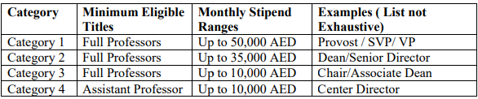
Sample review of January 2022 Payroll showed KUTC Center Director, who is an Associate Professor at KU has not been paid administrative stipend compared to other Center Directors at KU such as for ENTC and KUSTIC etc.
Recommendation
- Ensure faculty are compensated as per the policy.
Management Action Plan
Management Action Plan:

Responsibility:

Timelines:

Appendix

Appendix 1
Findings Rating
The audit findings have been grouped together in a logical manner to appropriately convey the risk and impact. The audit findings have been categorized based on their criticality rating as High, Medium and Low. The definitions of the findings criticality / distribution are provided in the table bel
 | Finding Rating | Definition | Number of Findings | Total
● | High | Finding is serious and deserves immediate attention by the Process Manager. The finding is reported to the Audit Committee quarterly. | 3 | 10
● | Medium | Finding impacts the accomplishment of the Process objectives. Corrective action is required by management. If not resolved, the finding could result in inefficient use of entity resources and or potentially disrupt business processes. | 5
● | Low | Finding to be reported to Management but is of a minor risk to the entity. Findings will not be reported to the Audit Committee unless the finding remains open after the follow up audit. | 2

Appendix 2

 | Finding Rating
Lack of information on Center Facilities | (https://www.ku.ac.ae/research-centers/uae-korea-joint-rd-technical-center-kutc-trashed/facilities) | 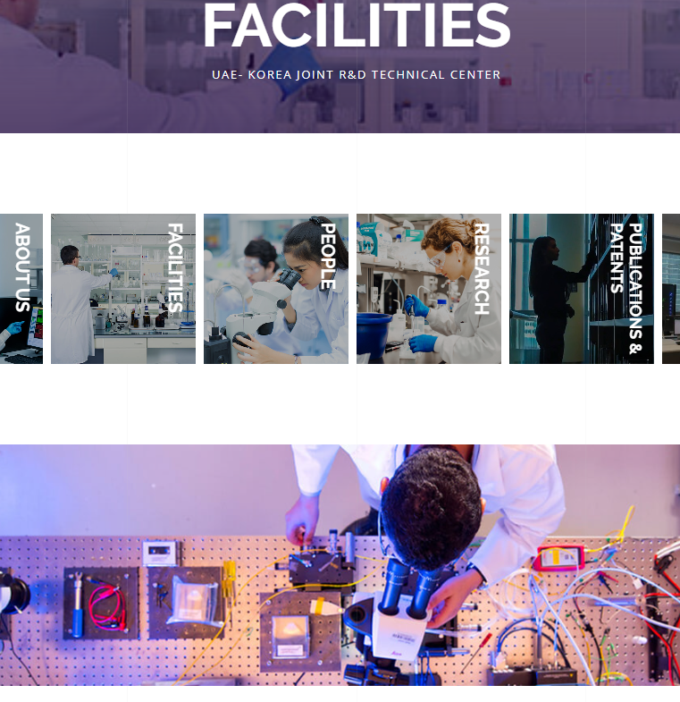
Lack of information on Center related Patents & Publications | (https://www.ku.ac.ae/research-centers/uae-korea-joint-rd-technical-center-kutc/publications-patents) | 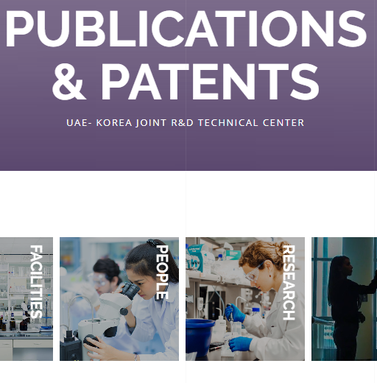
Obsolete information on Center Leadership / Board Members. | https://www.ku.ac.ae/research-centers/uae-korea-joint-rd-technical-center-kutc/people | 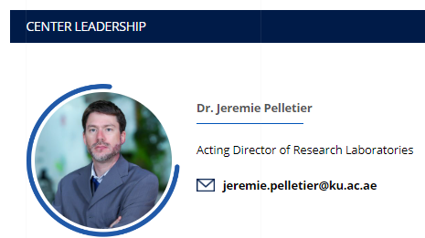

Appendix 3

Category | Amount Underutilized between 2019 - 2022
Personnel | 241,331
Personnel Benefits | 56,426
Travel | 20,185
Operational Expenses | 13,547
Total | 331,489

Appendix 4

Year | Expenditure reported in Project reports | Expenditure in ADERP System – Project Fund Report
2019 | 4,520 | 0
2020 | 35,000 | 246,292
2021 | Not reported | 287,828
2022 | Not reported | 215,940
 |  | 750,261

Snapshot:
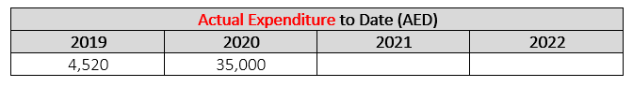
Source: 2022 Periodic Assessment Report (Research Project)

